**Data Visualization**

## **Data Visualization is the communication of data in a visual manner or turning raw data into insights that can be easily interpreted by your readers.**

## **The 17 Most Common Graph Types**

* Bar Chart
* Line Chart
* Scatterplot
* Sparkline
* Pie Chart
* Gauge
* Waterfall Chart
* Funnel Chart
* Heat Map
* Histogram
* Box Plot
* Maps
* Tables
* Indicators
* Area Chart
* Radar or Spider Chart
* Tree Map

## **1. Bar Chart**

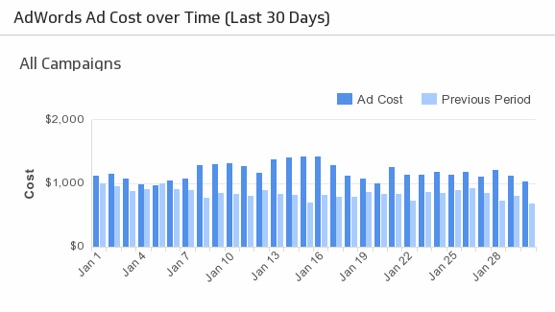

At some point or another, you've either seen, interacted with, or built a bar chart before. Bar charts are such a popular graph visualization because of how easy you can scan them for quick information. Bar charts organize data into rectangular bars that make it a breeze to compare related data sets.

### **When do I use a bar chart visualization?**

Use a bar chart for the following reasons:

* You want to compare two or more values in the same category
* You want to compare parts of a whole
* You don’t have too many groups (less than 10 works best)
* You want to understand how multiple similar data sets relate to each other

Don’t use a bar chart for the following reasons:

* The category you’re visualizing only has one value associated with it
* You want to visualize continuous data

### **Best practices for a bar chart visualization**

If you use a bar chart, here are the key design best practices:

* Use **consistent colours and labeling** throughout so that you can identify relationships more easily
* **Simplify the length of the y-axis** labels and don’t forget to **start from 0** so you can keep your data in order

## **2. Line Chart**

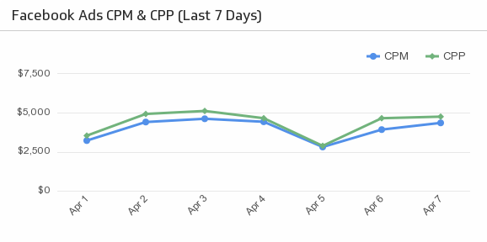

Like bar charts, line charts help to visualize data in a compact and precise format which makes it easy to rapidly scan information in order to understand trends. Line charts are used to show resulting data relative to a continuous variable - most commonly time or money. The proper use of color in this visualization is necessary because different colored lines can make it even easier for users to analyze information.

### **When do I use a line chart visualization?**

Use a line chart for the following reasons:

* You want to understand trends, patterns, and fluctuations in your data
* You want to compare different yet related data sets with multiple series
* You want to make projections beyond your data

Don’t use a line chart for the following reason:

* You want to demonstrate an in-depth view of your data

### **Best practices for a line chart visualization**

If you use a line chart, here are the key design best practices:

* Along with using a **different colour** for each category you’re comparing, make sure you also use solid lines to keep the line chart clear and concise
* To avoid confusion, try **not to compare more than 4 categories** in one line chart

## **3. Scatterplot**



Scatterplots are the right data visualizations to use when there are many different data points, and you want to highlight similarities in the data set. This is useful when looking for outliers or for understanding the distribution of your data.

If the data forms a band extending from lower left to upper right, there most likely a positive correlation between the two variables. If the band runs from upper left to lower right, a negative correlation is probable. If it is hard to see a pattern, there is probably no correlation.

### **When do I use a scatter plot visualization?**

Use a scatterplot for the following reasons:

* You want to show the relationship between two variables
* You want a compact data visualization

Don’t use a scatterplot for the following reasons:

* You want to rapidly scan information
* You want clear and precise data points

### **Best practices for a scatter plot visualization**

If you use a scatterplot, here are the key design best practices:

* Although trend lines are a great way to analyze the data on a scatterplot, ensure you stick to **1 or 2 trend lines** to avoid confusion
* Don’t forget to **start at 0** for the y-axis

## **4. Sparkline**

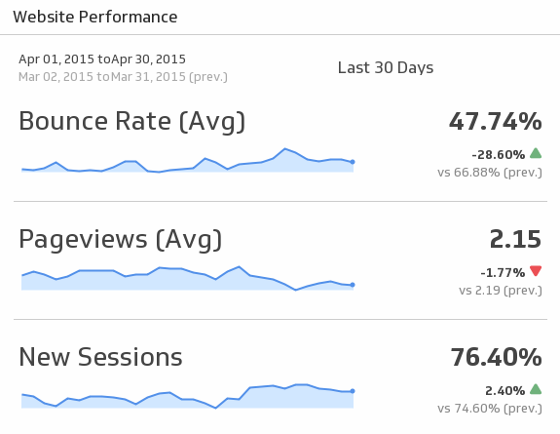

Sparklines are arguably the best data visualization for showing trends because of how compact they are. They get the job done when it comes to painting a picture for your audience fast. Though, it is important to make sure your audience understands how to read sparklines correctly to optimize their use.

### **When do I use a sparkline visualization?**

Use a sparkline for the following reasons:

* You can pair it with a metric that has a current status value tracked over a specific time period
* You want to show a specific trend behind a metric

Don’t use a sparkline for the following reasons:

* You want to plot multiple series
* You want to illustrate precise data points (i.e. individual values)

### **Best practices for a sparkline visualization**

If you use a sparkline, here are the key design best practices:

* To assist with readability, consider **adding indicators** on the side that give a better glimpse into the data, like in the example above
* Stick to **one colour** for your sparklines to keep them consistent on your dashboard

## **5. Pie Chart**

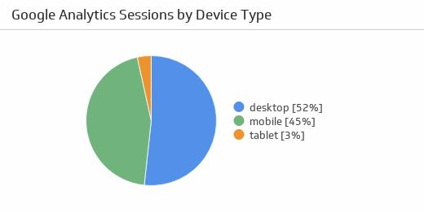

Pie charts are an interesting graph visualization. At a high-level, they're easy to read and understand because the parts-of-a-whole relationship is made very obvious. But top data visual experts agree that one of their disadvantages is that the percentage of each section isn’t obvious without adding numerical values to each slice of the pie.

*So, what’s the point?* As long as you stick to best practices, pie charts can be a quick way to scan information.

### **When do I use a pie chart visualization?**

Use a pie chart for the following reasons:

* You want to compare relative values
* You want to compare parts of a whole
* You want to rapidly scan metrics

Don’t use a pie chart for the following reason:

* You want to precisely compare data

### **Best practices for a pie chart visualization**

If you use a pie chart, here are the key design best practices:

* Make sure that the pie slices **add up to 100%**. To make this easier, add the numerical values and percentages to your pie chart
* Order the pieces of your pie according to size
* Use a pie chart if you have only **up to 5 categories** to compare. If you have too many categories, you won’t be able to differentiate between the slices

## **6. Gauge**

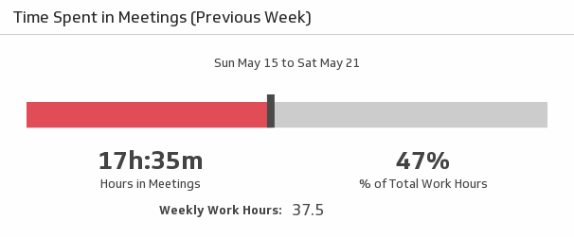

Gauges typically only compare two values on a scale: they compare a current value and a target value, which often indicates whether your progress is either good or bad, in the green or in the red.

### **When do I use a gauge visualization?**

Use a gauge for the following reason:

* You want to track single metrics that have a clear, in the moment objective

Don’t use a gauge for the following reasons:

* You want to track multiple metrics
* You’re looking to visualize precise data points

### **Best practices for a gauge visualization**

If you use a gauge, here are the key design best practices:

* Feel free to **play around with the size and shape** of the gauge. Whether it’s an arc, a circle or a line, it’ll get the same job done
* Keep the **colours consistent** with what means “good” or “bad” for you and your numbers
* Use **consistent colours and labeling** throughout so that you can identify relationships more easily
* **Simplify the length of the y-axis** labels and don’t forget to **start from 0** so you can keep your data in order

## **7. Waterfall Chart**

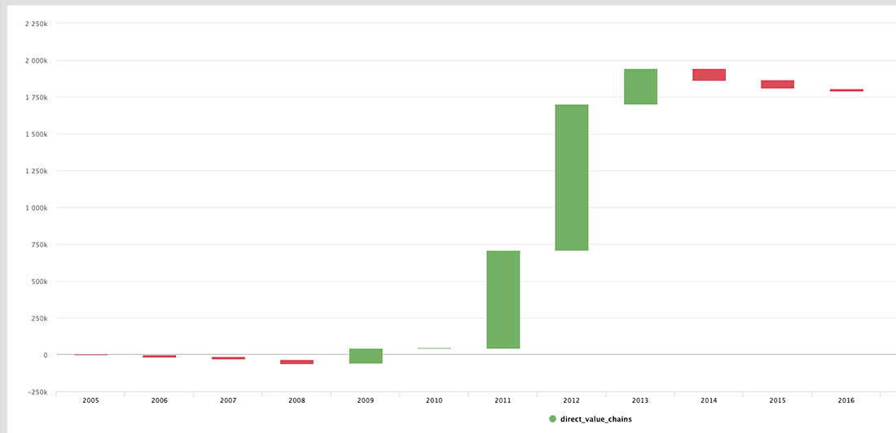

A waterfall chart is an information visualization that should be used to show how an initial value is affected by intermediate values and resulted in a final value. The values can be either negative or positive.

### **When do I use a waterfall chart visualization?**

Use a waterfall chart for the following reason:

* To reveal the composition or makeup of a number

Don’t use a waterfall chart for the following reason:

* You want to focus on more than one number or metric

### **Best practices for a waterfall chart visualization**

If you use a waterfall chart, here are the key design best practices:

* Use **contrasting colors** to highlight differences in data sets
* Choose **warm colors** to indicate increases and **cool colors** to indicate decreases

## **8. Funnel Chart**

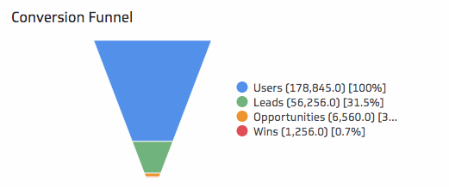

A funnel chart is your data visualization of choice if you want to display a series of steps and the completion rate for each step. This can be used to track the sales process, a marketing funnel or the conversion rate across a series of pages or steps. Funnel charts are most often used to represent how something moves through different stages in a process. A funnel chart displays values as progressively decreasing proportions amounting to 100 percent in total.

### **When do I use a funnel chart visualization?**

Use a funnel chart for the following reason:

* To display a series of steps and each step’s completion rate

Don’t use a funnel chart for the following reason:

* To visualize individual, unconnected metrics

### **Best practices for a funnel chart visualization**

If you use a funnel chart, here are the key design best practices:

* **Scale the size of each section** to accurately reflect the size of its data set
* **Use contrasting colors or one color** in gradating hues, from darkest to lightest as the size of the funnel decreases

## **9. Heat Map**

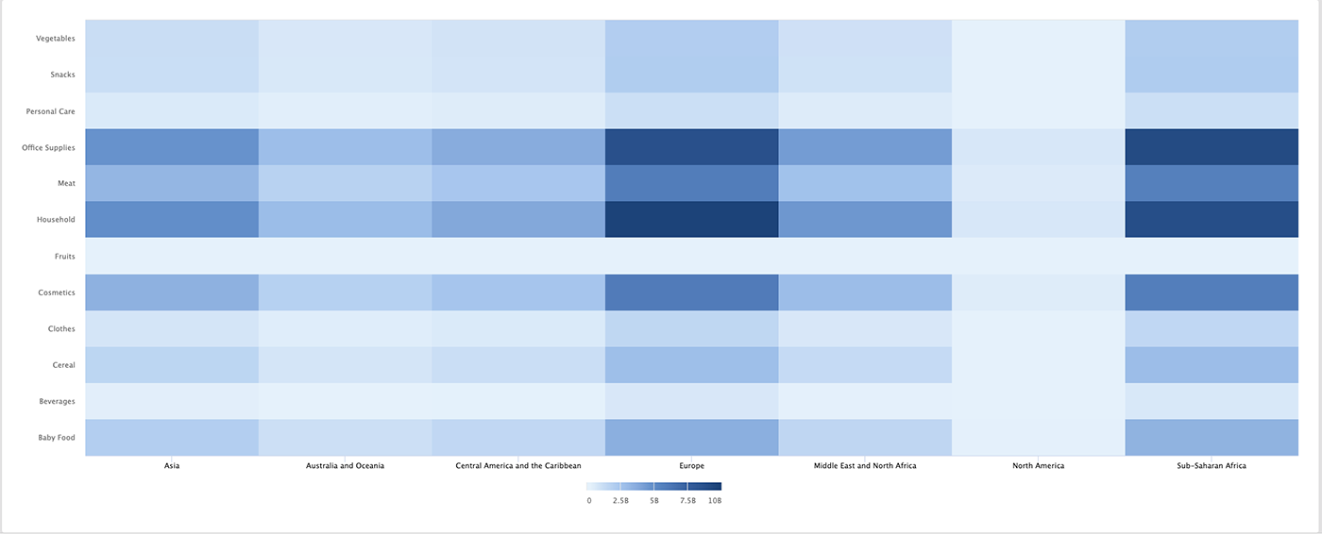

A heat map or choropleth map is a data visualization that shows the relationship between two measures and provides rating information. The rating information is displayed using varying colors or saturation and can exhibit ratings such as high to low or bad to awesome, and needs improvement to working well.

It can also be a thematic map in which the area inside recognized boundaries is shaded in proportion to the data being represented.

### **When do I use a heat map visualization?**

Use a heat map for the following reasons:

* To show a relationship between two measures
* To illustrate an important detail
* To use a rating system

Don’t use a heat map for the following reason:

* To visualize individual, unconnected metrics

### **Best practices for a heat map visualization**

If you use a heat map, here are the key design best practices:

* Use a **simple map outline** to avoid distracting from the data
* Use a **single color in varying shades** to show changes in data
* Avoid using **multiple patterns**

## **10. Histogram**

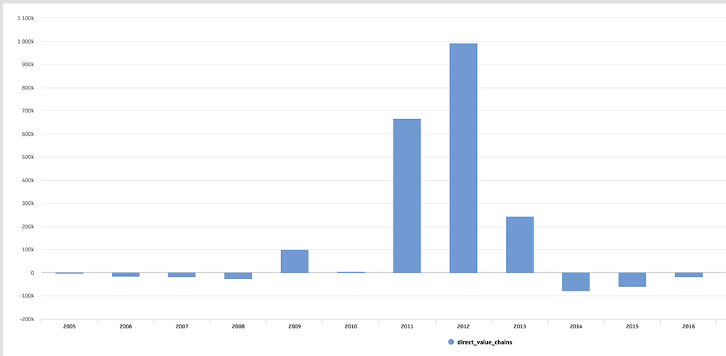

A histogram is a data visualization that shows the distribution of data over a continuous interval or certain period. It's a combination of a vertical bar chart and a line chart. The continuous variable shown on the X-axis is broken into discrete intervals and the number of data you have in that discrete interval determines the height of the bar.

Histograms give an estimate as to where values are concentrated, what the extremes are, and whether there are any gaps or unusual values throughout your data set.

### **When do I use a histogram visualization?**

Use a histogram for the following reason:

* To make comparisons in data sets over an interval or time
* To show a distribution of data

Don’t use a histogram for the following reason:

* To compare 3+ variables in data sets

### **Best practices for a histogram visualization**

If you use a histogram, here are the key design best practices:

* Avoid bars that are **too wide** that can hide important details or **too narrow** that can cause a lot of noise
* Use **equal round numbers** to create bar sizes
* Use **consistent colors and labeling** throughout so that you can identify relationships more easily

## **11. Box Plot**

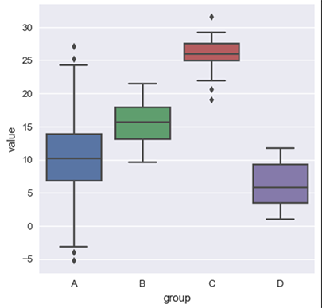

(Source: Python Graph Gallery)

A box plot, or box and whisker diagram, is a visual representation of displaying a distribution of data, usually across groups, based on a five-number summary: the minimum, first quartile, the median (second quartile), third quartile, and the maximum.

The simplest box plots display the full range of variation from minimum to maximum, the likely range of variation, and a typical value. A box plot will also show the outliers.

### **When do I use a box plot visualization?**

Use a box plot for the following reasons:

* To display or compare the distribution of data
* To identify the minimum, maximum, and median of data

Don’t use a box plot for the following reason:

* To visualize individual, unconnected data sets

### **Best practices for a box plot visualization**

If you use a box plot, here are the key design best practices:

* Ensure **font sizes for labels and legends are big enough** and **line widths are thick enough** to understand the findings easily
* If plotting multiple datasets, use **different symbols, line styles, or colors** to differentiate each
* Always **remove unnecessary clutter** from the plots

## **12. Maps**

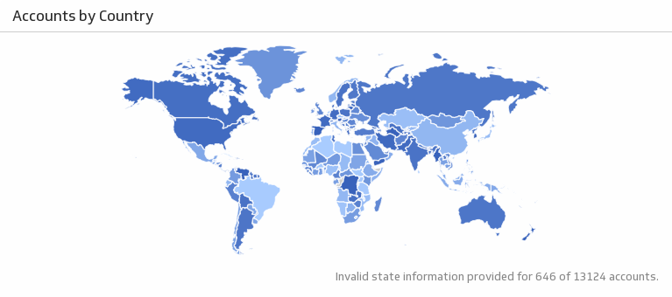

[*I want the map above in my business dashboard!*](https://app.klipfolio.com/dashboard?template=4f23254a4d5aa6170b80bbca8f405097)

Maps are an amazing visualization to add to your dashboard if organizing data geographically tells an important story for your business. For example, if your dashboard is looking at monthly sales, it could be extremely useful to see the geographic locations of your customers.

Above, you’ll find a map visualization that integrates with Salesforce to measure accounts by country. Keep in mind that if your dashboard is looking at daily sales, this visualization may provide less value to your day-to-day discussions.

### **When do I use a map visualization?**

Use a map for the following reason:

* Geography is an important part of your data story

Don’t use a map for the following reasons:

* You want to show precise data points
* Geography is not an important element of the dashboard’s overarching story

### **Best practices for a map visualization**

If you use a map visualization, here are the key design best practices:

* **Avoid using multiple colors** and patterns on your map. Use varying shades of the same color instead
* Make sure to **include a legend** with your map, so that everyone understands what the data means

## **13. Tables**

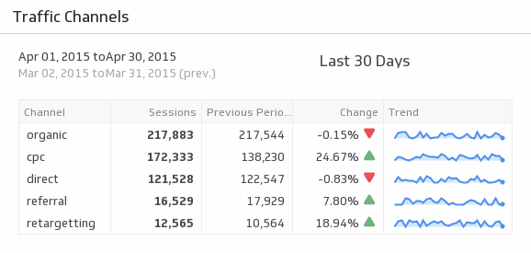

[*I want the table above in my business dashboard!*](https://app.klipfolio.com/dashboard/add_template/kliptemplate_cd66a48a1e62ddad36fc366550b99579)

If you’re someone who wants a little bit of everything in front of you to make thorough decisions, then tables are the visualization to go with. Tables are great because you can display both data points and graphics, such as bullet charts, icons, and sparklines. This visualization type also organizes your data into columns and rows, which is great for reporting.

Above is an example of how to bring your Google Analytics data into a table, so that you can see all the information you need in one place.

One thing to keep in mind is that tables can sometimes be overwhelming if you have a dashboard with many metrics that you want to display. It's important to find a happy medium between large amounts of data (confusing) and too little data (waste of dashboard space).

### **When do I use a table visualization?**

Use a table for the following reasons:

* You want to display two-dimensional data sets that can be organized categorically
* You can drill down to break up large data sets with a natural drill-down path

Don’t use a table for the following reason:

* You want to display large amounts of data

### **Best practices for a table visualization**

If you use a table, here are the key design best practices:

* **Be mindful of the order** of the data. Make sure that labels, categories, and numbers come first then move on to the graphics
* Try not to have more than 10 different rows on your table to **avoid clutter**

## **14. Indicators**

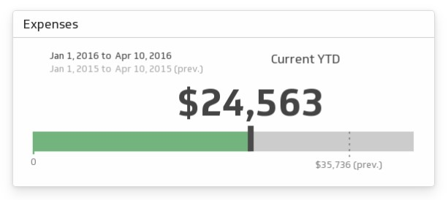

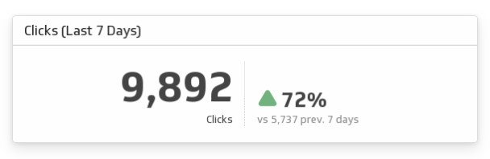

Indicators are useful for a glance view of a metric you need to keep track of. An indicator is simply a number showing the current value of whichever performance metric you’re tracking. To make it more useful, add a comparison to the previous period to show whether your metric is tracking up or down.

Some people like to get fancy with indicators and use gauges or tickers. They present the same type of information, just in a different visual way.

## **15. Area Chart**



An area chart is very similar to a line graph but may do a better job of highlighting the relative differences between items. Use an area chart when you want to see how different items stack up or contribute to the whole.

## **16. Radar or Spider Chart**



A radar chart is useful for understanding the relative differences between items in your data. Radar charts make it easy to compare multiple items and see if there are differences that may be worth further investigation.

## **17. Treemap**

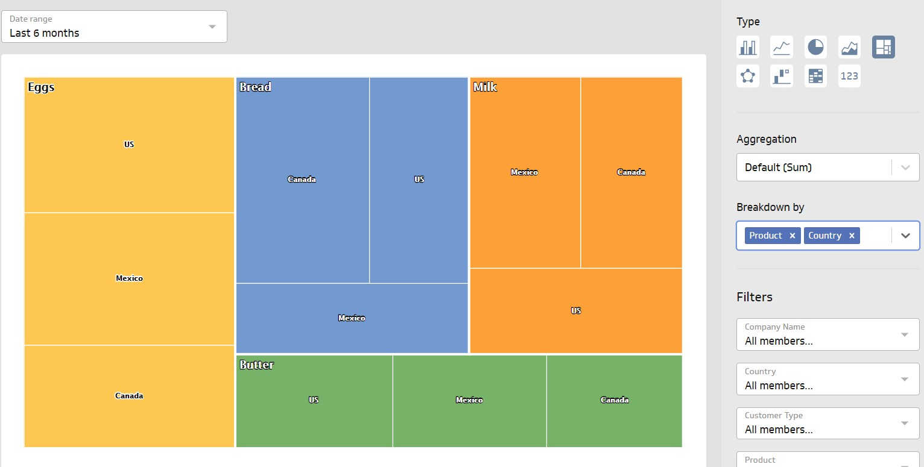

A treemap is a visual tool that can be used to break down the relationships between multiple variables in your data. They can be used strictly as a presentation vehicle to show how your products roll up into different categories, for example. A treemap can be broken down into 2-3 different layers to show the hierarchical relationship between items.